
Lab Report - 02

COURSE CODE: CSE-2340
COURSE TITLE: SOFTWARE DEVELOPMENT 1

LAB TOPIC:
Marks:
Signature:
JAVA PRACTICE PROBLEM
SUBMITTED TO:
Md. Sadman Hafiz
Lecturer
Department of CSE, IIUC
SUBMISSION DATE:
08-04-2026
SUBMITTED BY:
Name : Makhnoon Mahira Kabir
ID No : C251227
Semester : 3rd
Section : 3AF
Department: CSE
SET-01 (Beginner)
Problem-01:
Print "Hello, World!”

Code :
package hello_world.c251227;
public class Hello_WorldC251227 {
public static void main(String[] args) {
System.out.println("Hello World!");
}
}

Output :

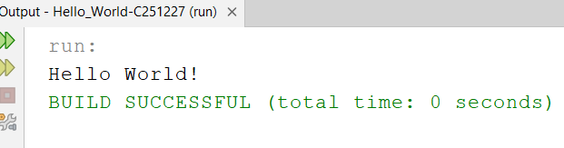

Discussion :
In this program, a basic Java class and main method were created.The System.out.println() statement was used to display a message.No input was required in this program.When the program runs, it directly prints “Hello World!” on the console.This shows the simplest structure of a Java program.

Problem-02:
Take the user’s name and greet them. Example, Input: “Your Name” and Output: Hello, “Your Name”!

Code :
package name.greet.c251227;
import java.util.Scanner;
public class NameGreetC251227 {
public static void main(String[] args) {
Scanner sc = new Scanner(System.in);
System.out.println("Your Name: ");
String name = sc.nextLine();
System.out.println("Hello " + name + "!");
}
}

Output :

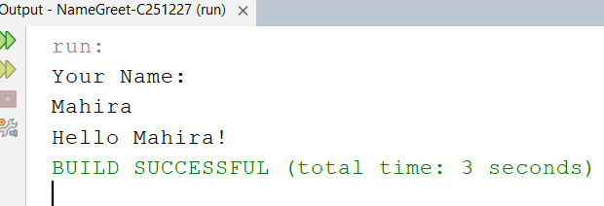

Discussion :
In this program, the Scanner class was used to take user input.The user enters a name which is stored in a variable.This value is then concatenated with a greeting message.System.out.println() prints the final output.The output dynamically changes based on user input.

Problem-03:
Check if a number is even or odd.

Code :
package even_odd.c251227;
import java.util.Scanner;
public class Even_OddC251227 { public static void main(String[] args) {
Scanner sc =new Scanner(System.in);
int n = sc.nextInt();
if (n % 2 == 0) {
System.out.println("Even");
} else {
System.out.println("Odd");
}
}
}

Output :

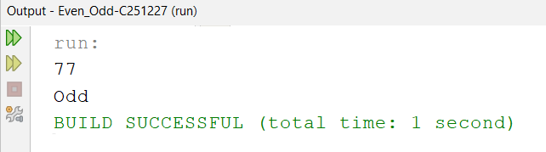

Discussion :
In this program, a number was taken as input from the user.The modulus operator % was used to check divisibility by 2.If the remainder is 0, the number is even.Otherwise, it is considered odd.Here,the result is 77 which is odd.

Problem-04:
Find the maximum of 3 numbers: Take 3 numbers from user input, print the largest.

Code :
package maximum.c251227;
import java.util.Scanner;
public class MaximumC251227 {
public static void main(String[] args) {
Scanner sc = new Scanner(System.in);
int a =sc.nextInt();
int b =sc.nextInt();
int c =sc.nextInt();
int max = a;
if(b > max){
max = b; }
if (c > max){
max = c; }
System.out.println("Largest number:"+ max);
}
}

Output :

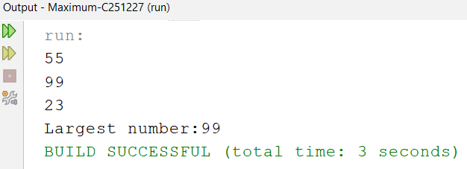

Discussion :
In this program, three numbers were taken as input.A variable max was used to store the largest value.
Conditional if statements were used to compare values.The largest number replaces the previous value in max.
Finally, the maximum number is printed as output.

Problem-05:
Simple Calculator (Add, Subtract, Multiply, Divide): Use if-else or switch to perform
Operations.

Code :
package calculator.c51227;
import java.util.Scanner;
public class CalculatorC51227 {
public static void main(String[] args) {
Scanner sc = new Scanner(System.in);
int a = sc.nextInt();
int b = sc.nextInt();
char op = sc.next().charAt(0);
if (op == '+') {
System.out.println(a + b);
} else if (op == '-') {
System.out.println(a - b);
} else if (op == '*') {
System.out.println(a * b);
} else if (op == '/') {
System.out.println(a / b);
} else {
System.out.println("Invalid operator"); }
}
}

Output :

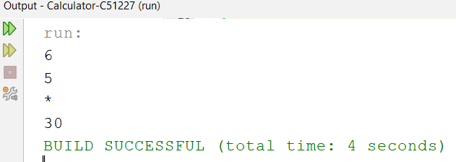

Discussion :
This program takes two numbers and an operator as input.Based on the operator, a specific operation is performed.if-else conditions were used for different cases.The result is calculated and printed accordingly.Invalid operators show an error message.

Problem-06:
Print numbers from 1 to N. Take N from the user input.

Code :
package printnum.c251227;
import java.util.Scanner;
public class PrintnumC251227 {
public static void main(String[] args) {
Scanner sc = new Scanner(System.in);
int n = sc.nextInt();
for( int i =1 ;i<=n;i++){
System.out.println("Printing Numbers: " + i); }
}
}

Output :

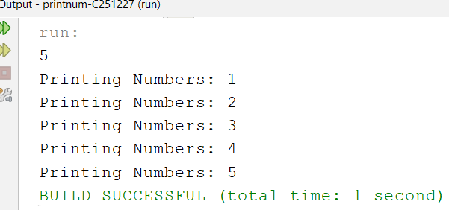

Discussion :
In this program, a number N was taken as input. A for loop was used to iterate from 1 to N.In each iteration, the value of i is printed.The loop continues until the condition becomes false.This produces sequential output from 1 to N.

Problem-07:
Print the multiplication table of a number.

Code :
package multiplication.c251227;
import java.util.Scanner;
public class MultiplicationC251227 {
public static void main(String[] args) {
Scanner sc = new Scanner(System.in);
int n = sc.nextInt();
for (int i =1;i<=n;i++) {
System.out.println(n + " x " + i + " = " + (n * i)); }
}
}

Output :

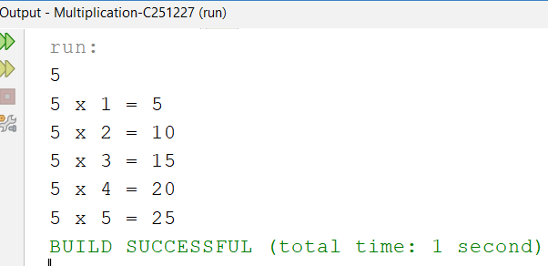

Discussion :
In this program, an integer value was taken as input from the user.A for loop was used to generate the multiplication table.The loop starts from 1 and continues up to the given number.In each iteration, the input number is multiplied by the loop variable.The result is formatted and displayed using System.out.println().
This helps in understanding loop iteration and arithmetic operations.The output shows step-by-step multiplication results.Each line represents one step of the multiplication table.

Problem-08:
Calculate the factorial of a number. Example: 5! = 5 × 4 × 3 × 2 × 1 = 120

Code :
package factorial.c251227;
import java.util.Scanner;
public class FactorialC251227 {
public static void main(String[] args) {
Scanner sc = new Scanner(System.in);
int n = sc.nextInt();
int fact = 1;
for(int i = 1;i<= n;i++) {
fact = fact*i; }
System.out.println("Factorial = " + fact);
}
}

Output :

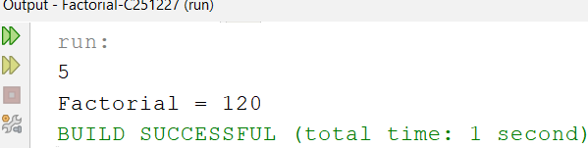

Discussion :
In this program, a number was taken as input from the user.A variable fact was initialized to 1 to store the result.A for loop was used to multiply numbers from 1 to N.In each iteration, the value of fact is updated.
This process continues until the loop ends.The final value represents the factorial of the number.
The result is printed using an output statement.This demonstrates repeated multiplication using loop.

Problem-09:
Sum of all numbers from 1 to N.

Code :
package sum.c251227;
import java.util.Scanner;
public class SumC251227 {
public static void main(String[] args) {
Scanner sc = new Scanner(System.in);
int n = sc.nextInt();
int sum=0;
for(int i=1;i<=n;i++){
sum+=i;}
System.out.println("Sum of all numbers:"+sum);
}
}

Output :

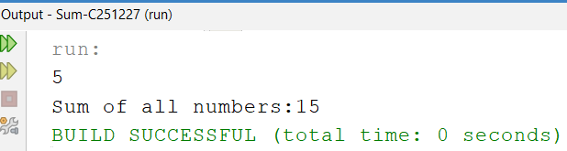

Discussion :
In this program, a number N was taken as input.A variable sum was initialized to store the result.A for loop iterates from 1 to N.In each iteration, the current value is added to sum.The sum increases step by step.This process continues until all values are added.Finally, the total sum is printed.This shows how accumulation works in loops.

SET-02 (Intermediate)
Problem-01:
Store and print 5 numbers in an array.

Code :
package store_printarr.c251227;
import java.util.Scanner;
public class Store_printarrC251227 {
public static void main(String[] args) {
Scanner sc = new Scanner(System.in);
int[] arr = new int[5];
for(int i = 0; i < 5; i++) {
arr[i] = sc.nextInt(); }
for(int i = 0; i < 5; i++) {
System.out.println(arr[i]);}
}
}

Output :

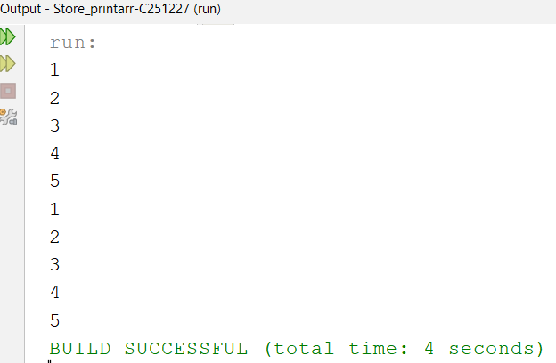

Discussion :
In this program, an array of size 5 was declared.A loop was used to take input values from the user.Each value was stored in the array using indexing.Another loop was used to access each element.The stored values were printed one by one.This demonstrates how arrays store multiple values.It also shows traversal using loops.The output displays all input values sequentially.

Problem-02:
Find the largest number in an array.

Code :
package largest_arr.c251227;
import java.util.Scanner;
public class Largest_arrC251227 {
public static void main(String[] args) {
Scanner sc = new Scanner (System.in);
int[] arr = new int[5];
for (int i =0; i < arr.length; i++)
arr[i] = sc.nextInt();
int max = arr[0];
for (int i = 1; i < arr.length; i++) {
if (arr[i] > max) {
max = arr[i]; } }
System.out.println("Largest = " + max);
}
}

Output :

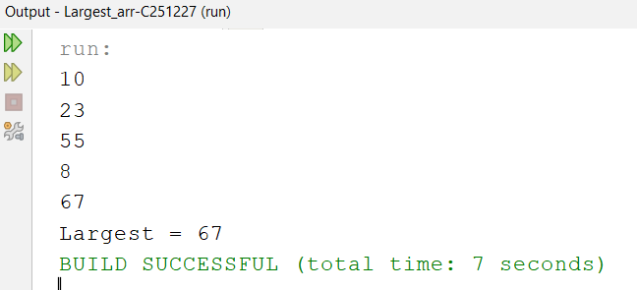

Discussion :
In this program, an array was filled with user input.The first element was assumed as the maximum value.A loop was used to compare each element with the maximum.If a larger value was found, the maximum was updated.This process continues for all elements.After completing the loop, the largest value is determined.
The result is printed using an output statement.This shows comparison logic in arrays.

Problem-03:
Find the smallest number in an array.

Code :
package smallest_arr.c251227;
import java.util.Scanner;
public class Smallest_arrC251227 {
public static void main(String[] args) {
Scanner sc = new Scanner(System.in);
int[] arr = new int[5];
for (int i = 0; i < arr.length; i++) {
arr[i] = sc.nextInt(); }
int min = arr[0];
for (int i = 1; i <arr.length; i++) {
if (arr[i] < min) {
min = arr[i]; }}
System.out.println("Smallest = " + min);
}
}

Output :

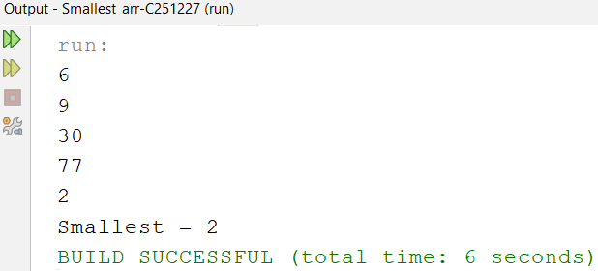

Discussion :
In this program, an array of numbers was created.The first element was taken as the initial minimum.A loop was used to compare each element.If a smaller value was found, it updated the minimum.This process continued until all elements were checked.The smallest value was stored in a variable.Finally, it was printed as output.This demonstrates searching in arrays.

Problem-04:
Calculate the average of an array.

Code :
package average.c251227;
import java.util.Scanner;
public class AverageC251227 {
public static void main(String[] args) {
Scanner sc = new Scanner(System.in);
int[] arr = new int[5];
int sum = 0;
for (int i = 0; i <arr.length; i++) {
arr[i] = sc.nextInt();
sum += arr[i]; }
double avg = (double) sum / 5;
System.out.println("Average = " + avg); }
}

Output :

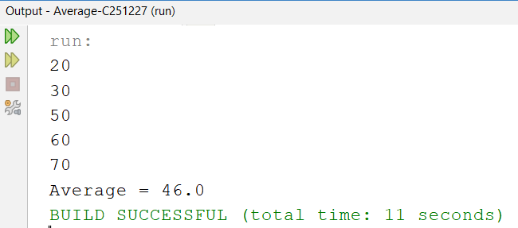

Discussion :
In this program,array elements were taken as input.A variable sum was to store total values.A loop added all elemnts into the sum.The average was calculated by dividing sum by size.Type casting used to get decimal point.The result was stored in a variable.Finally,the average value was printed.This show arithmetic operation on arrays.

Problem-05:
Count even and odd numbers in an array.

Code :
package even_odd_arr.c251227;
import java.util.Scanner;
public class Even_odd_arrC251227 {
public static void main(String[] args) {
Scanner sc = new Scanner(System.in);
int[] arr = new int[5];
int even = 0, odd = 0;
System.out.println("Enter 5 numbers:");
for (int i = 0; i < 5; i++) {
arr[i] = sc.nextInt();
if (arr[i] % 2 == 0) {
even++;
} else {
odd++; } }
System.out.println("Even = " + even);
System.out.println("Odd = " + odd); } }

Output :

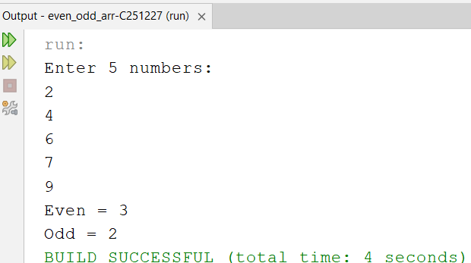

Discussion :
In this program, an array was filled with user input.Each element was checked using modulus operator %.If the number is divisible by 2, it is even.Otherwise, it is considered odd.Two counters were used to count even and odd values.The counters were updated in each iteration.After the loop, both counts were printed.This demonstrates condition checking in arrays.

Problem-06:
Search for an element in an array.

Code :
package search_element.c251227;
import java.util.Scanner;
public class Search_elementC251227 {
public static void main(String[] args) {
Scanner sc = new Scanner(System.in);
int[] arr = new int[5];
boolean found = false;
for (int i = 0; i < arr.length; i++) {
arr[i] = sc.nextInt(); }
System.out.print("Enter number to search: ");
int key = sc.nextInt();
for (int i = 0; i < arr.length; i++) {
if (arr[i] == key) {
found = true;
break; } }
if (found) {
System.out.println("Found");
} else {
System.out.println("Not Found"); } } }

Output :

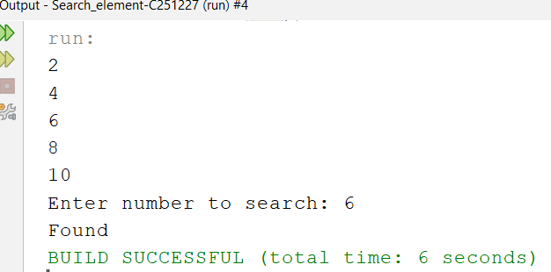

Discussion :
In this program, an array was created and filled.A key value was taken as input for searching.A loop was used to compare each element with the key.If a match was found, a flag variable was updated.The loop was terminated using break.After the loop, the result was checked.If found, “Found” was printed.Otherwise, “Not Found” was displayed.

Problem-07:
Sort an array (Ascending Order).

Code :
package sort_array.c251227;
import java.util.Scanner;
public class Sort_arrayC251227 {
public static void main(String[] args) {
Scanner sc = new Scanner(System.in);
int[] arr = new int[5];
for (int i = 0; i < arr.length; i++) {
arr[i] = sc.nextInt(); }
for (int i = 0; i < 5; i++) {
for (int j = i + 1; j <arr.length; j++) {
if (arr[i] > arr[j]) {
int temp = arr[i];
arr[i] = arr[j];
arr[j] = temp } } }
System.out.println("Sorted array:");
for (int i = 0; i <arr.length; i++) {
System.out.print(arr[i] + " "); } }
}

Output :

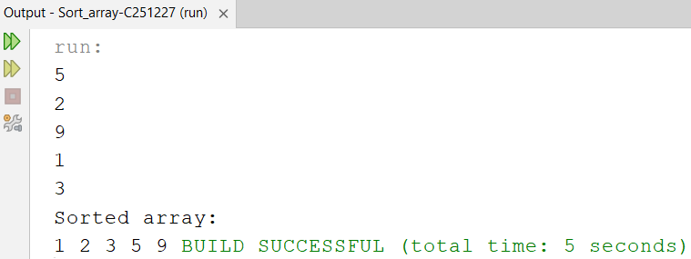

Discussion :
In this program, an array was taken as input.Nested loops were used to compare elements.If elements were in the wrong order, they were swapped.A temporary variable was used for swapping.This process repeated until sorting was complete.The array was arranged in ascending order.Finally, the sorted array was printed.This demonstrates basic sorting technique.

Problem-08:
Check if a string is a palindrome.

Code :
package palindrome.c251227;
import java.util.Scanner;
public class PalindromeC251227 {
public static void main(String[] args) {
Scanner sc =new Scanner(System.in);
System.out.print("Enter string: ");
String str = sc.next();
String rev = "";
for (int i = str.length() - 1; i >= 0; i--) {
rev += str.charAt(i); }
if (str.equals(rev)) {
System.out.println("Palindrome");
} else {
System.out.println("Not Palindrome"); } }
}

Output :

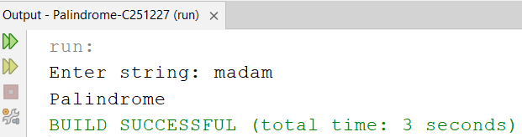

Discussion :
In this program, a string was taken as input.A loop was used to reverse the string.Each character was added in reverse order.The reversed string was stored separately.The original and reversed strings were compared.If both are equal, it is a palindrome.Otherwise, it is not a palindrome.The result was printed accordingly.

Problem-09:
Count vowels and consonants in a string.

Code :
package count_vow_cons.c251227;
import java.util.Scanner;
public class Count_vow_consC251227 {
public static void main(String[] args) {
Scanner sc = new Scanner(System.in);
String str = sc.next().toLowerCase();
int v = 0, c = 0;
for (int i = 0; i < str.length(); i++) {
char ch = str.charAt(i);
if (ch >= 'a' && ch <= 'z') {
if (ch == 'a' || ch == 'e' || ch == 'i' || ch == 'o' || ch == 'u') {
v++;
} else {
c++; } } }
System.out.println("Vowels = " + v);
System.out.println("Consonants = " + c);
}
}

Output :

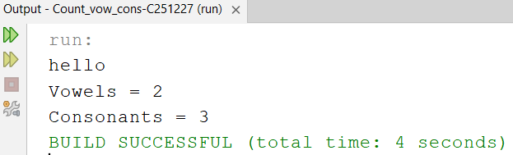

Discussion :
In this program, a string was taken as input.The string was converted to lowercase.A loop checked each character individually.Conditions were used to identify vowels.Vowel and consonant counters were updated.
Non-alphabet characters were ignored.Finally, total vowels and consonants were printed.
This shows string processing in Java.

Problem-10:
Convert a string to uppercase and lowercase.

Code :
package converting.c251227;
import java.util.Scanner;
public class ConvertingC251227 {
public static void main(String[] args) {
Scanner sc = new Scanner(System.in);
System.out.print("Enter string: ");
String str = sc.nextLine();
System.out.println("Uppercase: " + str.toUpperCase());
System.out.println("Lowercase: " + str.toLowerCase());
}
}

Output :

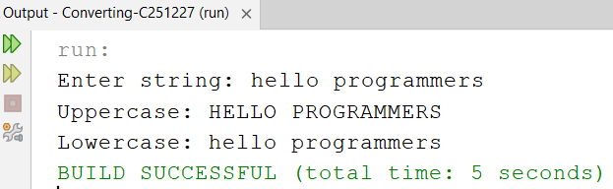

Discussion :
In this program, a string was taken from the user.Built-in methods were used for conversion.toUpperCase() converts all letters to uppercase.toLowerCase() converts all letters to lowercase.Both results were stored and displayed.This shows how Java handles string transformations.No manual looping was required.The output shows both versions of the string.

SET-03 (Descriptive Problems)

Problem : 01

Code :
package set_3.problem.pkg1;
import java.util.Scanner;
public class Set_3Problem1 {
public static void main(String[] args) {
Scanner sc = new Scanner(System.in);
int A = sc.nextInt();
int C = sc.nextInt();
if ((A + C) % 2 == 0) {
int B = (A + C) / 2;
System.out.println("B = " + B);
} else {
System.out.println("No integer B exists"); }
}
}

Output :

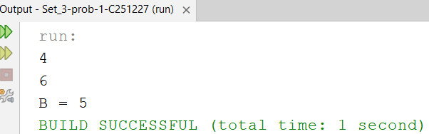

Discussion :
In this program, two integers A and C were taken as input from the user.The goal was to determine whether there exists an integer B such that B is the average of A and C.First, the sum of A and C was calculated.Then it was checked whether the sum is divisible by 2.If divisible, it ensures that the average is an integer value.The value of B was calculated using (A + C) / 2.If not divisible, it indicates no integer solution exists.The output is displayed based on this condition.

Problem : 02

Code :
package set_3.problem.pkg2;
import java.util.Scanner;
public class Set_3Problem2 {
public static void main(String[] args) {
Scanner sc = new Scanner(System.in);
String word = sc.next();
if (word.length() > 10) {
System.out.println("" + word.charAt(0) + (word.length() - 2) + word.charAt(word.length() - 1));
} else {
System.out.println(word); }
}
}

Output :

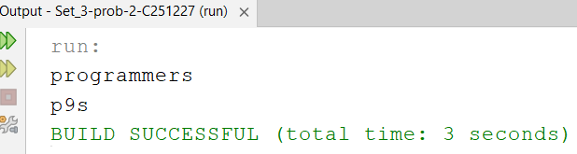

Discussion :
In this program, a word was taken as input from the user.The length of the word was determined using the length() method.If the length is greater than 10, the word is abbreviated.The abbreviation includes the first character, number of omitted characters, and last character.If the word length is 10 or less, it is printed as it is.This reduces long words into a shorter formatString indexing methods were used to access characters.Finally, the formatted output is displayed.

Problem : 03

Code:
package set_3.problem.pkg3;
import java.util.Scanner;
public class Set_3Problem3 {
public static void main(String[] args) {
Scanner sc = new Scanner(System.in);
String word = sc.next();
String result = Character.toUpperCase(word.charAt(0)) + word.substring(1);
System.out.println(result);
}
}

Output :

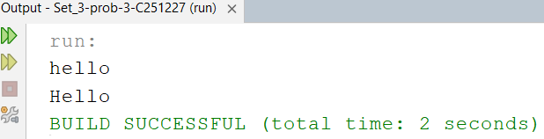

Discussion :
In this program, a string input was taken from the user.The objective was to capitalize the first letter of the word.The first character was converted to uppercase.The remaining substring was kept unchanged.Both parts were combined to form the final result.Methods like charAt() and substring() were used.This ensures proper formatting of text.The modified string was printed as output.

Problem : 04

Code:
package set_3.problem.pkg4;
import java.util.Scanner;
public class Set_3Problem4 {
public static void main(String[] args) {
Scanner sc = new Scanner(System.in);
int a = sc.nextInt();
int b = sc.nextInt();
int c = sc.nextInt();
if (a == b) {
System.out.println(c);
} else if (a == c) {
System.out.println(b);
} else {
System.out.println(a); }
}
}

Output :

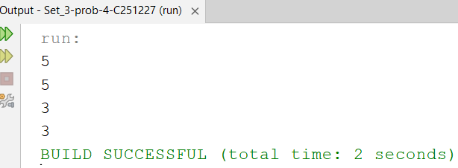

Discussion :
In this program, three integer values were taken as input.The objective was to find the unique number among them.If two numbers are equal, the third one is considered different.Conditional if-else statements were used to compare values.Each condition checks equality between pairs.Based on the condition, the unique number is identified.The result is printed accordingly.This demonstrates logical comparison between multiple values.

Problem : 05

Code :
package set_3.problem.pkg5;
import java.util.Scanner;
public class Set_3Problem5 {
public static void main(String[] args) {
Scanner sc = new Scanner(System.in);
int A = sc.nextInt();
int B = sc.nextInt();
int C = sc.nextInt();
double avg = (A + B) / 2.0;
if (avg > C) {
System.out.println("Yes");
} else {
System.out.println("No"); }
}
}

Output :

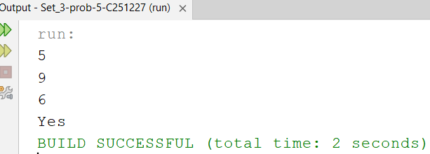

Discussion :
In this program, three integers A, B, and C were taken as input.The average of A and B was calculated.This average value was compared with C.If the average is greater than C, the condition is satisfied.In that case,“Yes” is printed.Otherwise, “No” is displayed.This demonstrates arithmetic and conditional logic.The output depends on the comparison result.

Problem : 06

Code:
package set_3.problem.pkg6;
import java.util.Scanner;
public class Set_3Problem6 {
public static void main(String[] args) {
Scanner sc = new Scanner(System.in);
int N = sc.nextInt();
int X = sc.nextInt();
int subscriptions = (N + 5) / 6; // round up
int cost = subscriptions * X;
System.out.println(cost);
}
}

Output :

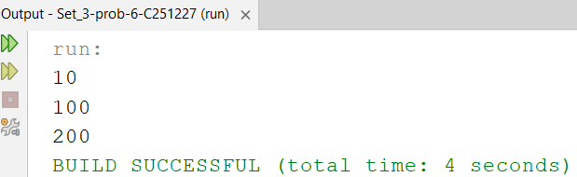

Discussion :
In this program, two integers N and X were taken as input.The number of subscriptions required was calculated.Each subscription covers 6 units, so division was performed.Rounding up logic was used to handle extra units.The total number of subscriptions was multiplied by X.This gave the total cost.Integer arithmetic was used carefully for accuracy.Finally, the total cost was printed.

Problem : 07

Code :
package set_3.problem.pkg7;
import java.util.Scanner;
public class Set_3Problem7 {
public static void main(String[] args) {
Scanner sc = new Scanner(System.in);
int X = sc.nextInt();
if (X + 3 <= 10) {
System.out.println("Yes");
} else {
System.out.println("No"); }
}
}

Output :

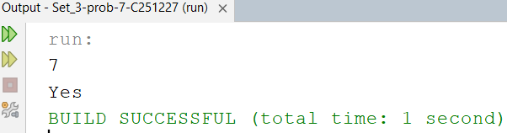

Discussion :
In this program, an integer X was taken as input.The program checks whether X + 3 is less than or equal to 10.A simple if-else condition was used.If the condition is true, “Yes” is printed.Otherwise, “No” is printed.This demonstrates basic arithmetic and comparison.The output depends on whether the condition is satisfied.This helps understand simple decision-making logic.

Problem : 08

Code :
package set_3.problem.pkg8;
import java.util.Scanner;
public class Set_3Problem8 {
public static void main(String[] args) {
Scanner sc = new Scanner(System.in);
int X = sc.nextInt();
int Y = sc.nextInt();
int Z = sc.nextInt();
int total = X * Y;
if (Z > total / 2) {
System.out.println("Yes");
} else {
System.out.println("No"); }
}
}

Output :

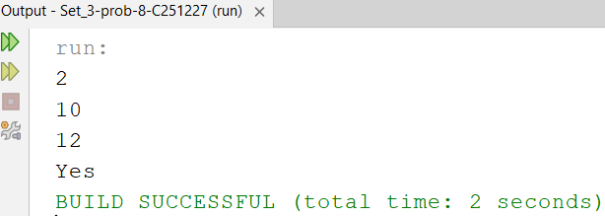

Discussion :
In this program, three integers X, Y, and Z were takenThe total possible value was calculated as X multiplied by Y.Then half of the total was determined.The value Z was compared with this half.If Z is greater than half, “Yes” is printed.Otherwise, “No” is displayedThis demonstrates multiplication and conditional comparison.The output reflects the comparison result.

Problem : 09

Code :
package set_3.problem.pkg9;
import java.util.Scanner;
public class Set_3Problem9 {
public static void main(String[] args) {
Scanner sc = new Scanner(System.in);
int X = sc.nextInt();
int Y = sc.nextInt();
int total = (4 * X) + Y;
System.out.println(total);
}
}

Output :

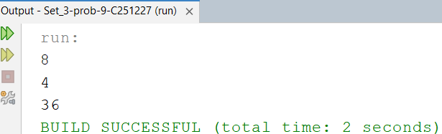

Discussion :
In this program, two integers X and Y were taken as input.A formula was applied to calculate the total value.The formula used was (4 * X) + Y.This represents a simple arithmetic expression.The result was stored in a variableNo condition was required in this program.The computed value was printed.This demonstrates basic calculation in Java.

Problem : 10

Code :
package set_3.problem.pkg10;
import java.util.Scanner;
public class Set_3Problem10 {
public static void main(String[] args) {
Scanner sc = new Scanner(System.in);
int b1 = sc.nextInt();
int b2 = sc.nextInt();
int b3 = sc.nextInt();
int empty = 0;
if (b1 == 0) empty++;
if (b2 == 0) empty++;
if (b3 == 0) empty++;
if (empty >= 2) {
System.out.println("Water filling time");
} else {
System.out.println("Not now"); }
}
}

Output :

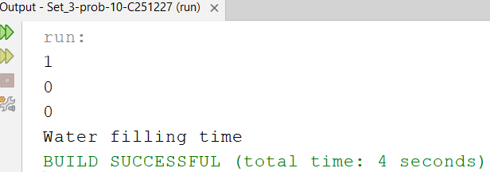

Discussion :
In this program, three integers were taken as input.Each value was checked to determine if it is zero.A counter variable was used to count empty values.For each zero value, the counter was increased.If two or more values are zero, a message is printed.Otherwise, another message is displayed.This demonstrates counting and condition checking.The output depends on the number of zero values.

Problem : 11

Code :
package set_3.problem.pkg11;
import java.util.Scanner;
public class Set_3Problem11 {
public static void main(String[] args) {
Scanner sc = new Scanner(System.in);
int N = sc.nextInt();
int notebooks = (N * 1000) / 100;
System.out.println(notebooks);
}
}

Output :

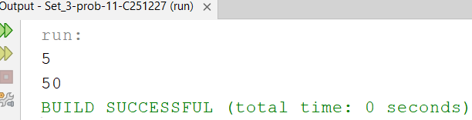

Discussion :
In this program, an integer N was taken as input.The number of notebooks was calculated using a formula.
Each notebook requires 100 pages.Given 1000 pages per unit, the calculation was done.The formula used was (N * 1000) / 100.The result gives total notebooks possible.The value was stored in a variable.Finally, the output was printed.

Problem : 12

Code :
package set_3.problem.pkg12;
import java.util.Scanner;
public class Set_3Problem12 {
public static void main(String[] args) {
Scanner sc = new Scanner(System.in);
int N = sc.nextInt();
int X = sc.nextInt();
int need = N - X;
if (need <= 0) {
System.out.println(0);
} else {
int packets = (need + 3) / 4;
System.out.println(packets); }
}
}

Output :

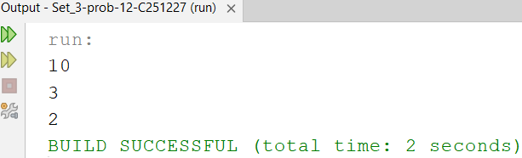

Discussion :
In this program, two integers N and X were taken.The remaining value was calculated as N - X.
If the remaining value is less than or equal to zero, output is 0Otherwise, packets were calculated using division.Each packet contains 4 units.Rounding up logic was used to cover extra units.The final packet count was determined.The result was printed accordingly.

Problem : 13

Code :
package set_3.problem.pkg13;
import java.util.Scanner;
public class Set_3Problem13 {
public static void main(String[] args) {
Scanner sc = new Scanner(System.in);
int A = sc.nextInt();
int B = sc.nextInt();
int C = sc.nextInt();
int X = sc.nextInt();
if (X == A || X == B || X == C) {
System.out.println("Yes");
} else {
System.out.println("No"); }
}
}

Output :

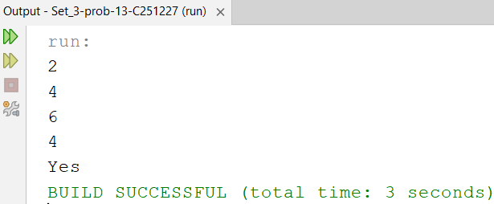

Discussion :
In this program, four integers were taken as input.The goal was to check if X matches any of A, B, or C.
Multiple conditions were used for comparison.Each condition checks equality between values.If any match is found, “Yes” is printed.Otherwise, “No” is displayed.This demonstrates multiple condition checking.The output depends on matching values.

Problem : 14

Code :
package set_3.problem.pkg14;
import java.util.Scanner;
public class Set_3Problem14 {
public static void main(String[] args) {
Scanner sc = new Scanner(System.in);
int P = sc.nextInt();
int Q = sc.nextInt();
int R = sc.nextInt();
int S = sc.nextInt();
if (P > Q + R + S || Q > P + R + S || R > P + Q + S || S > P + Q + R) {
System.out.println("Yes");
} else {
System.out.println("No"); }
}
}

Output :

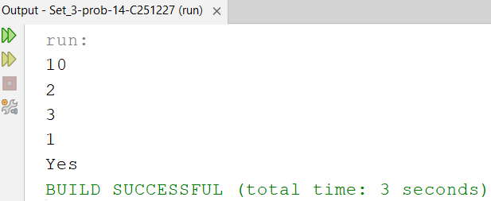

Discussion :
In this program, four integers were taken as input.Each number was compared with the sum of the other three.
If any number is greater than the sum of the rest, condition is true.Logical OR (||) was used to combine conditions.If the condition is satisfied, “Yes” is printed.Otherwise, “No” is displayed.This demonstrates complex condition checking.The output depends on the comparison results.
Problem : 15

Code :
package set_3.problem.pkg15;
import java.util.Scanner;
public class Set_3Problem15 {
public static void main(String[] args) {
Scanner sc = new Scanner(System.in);
int A = sc.nextInt();
int B = sc.nextInt();
int C = sc.nextInt();
int minTemp = Math.max(A, C);
if (minTemp <= B) {
System.out.println("Yes");
} else {
System.out.println("No"); }
}
}

Output :

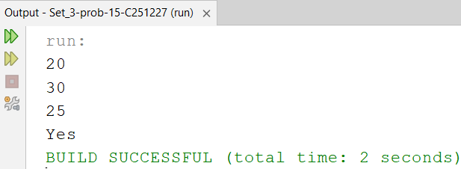

Discussion :
In this program, three integers A, B, and C were taken.The maximum value between A and C was found using Math.max().This value was compared with B.If B is greater than or equal to this value, condition is satisfied.In that case, “Yes” is printed.Otherwise, “No” is displayed.This demonstrates use of built-in functions.The output depends on the comparison result.

